**Banner: con FORMULARIO Sector**

<div role="main" id="form-pag-sector-5892720dec6abb38b543"></div><script type="text/javascript" src="https://d335luupugsy2.cloudfront.net/js/rdstation-forms/stable/rdstation-forms.min.js"></script><script type="text/javascript"> new RDStationForms('form-pag-sector-5892720dec6abb38b543', 'UA-19986828-1').createForm();</script>

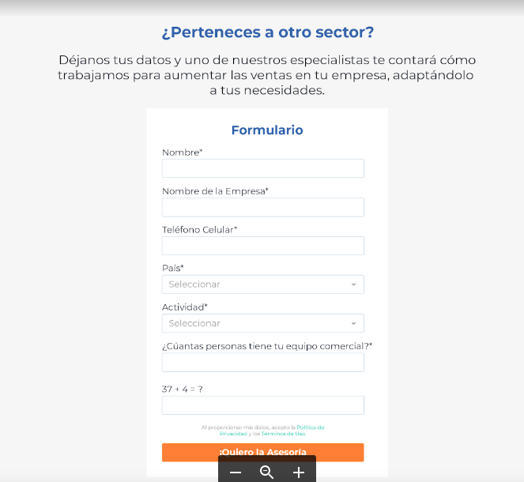

**Banner: con FORMULARIO RD partners**

<div role="main" id="form-pag-partner-ca6431af6c200e98ac58"></div><script type="text/javascript" src="https://d335luupugsy2.cloudfront.net/js/rdstation-forms/stable/rdstation-forms.min.js"></script><script type="text/javascript"> new RDStationForms('form-pag-partner-ca6431af6c200e98ac58', 'UA-19986828-1').createForm();</script>

